General Manager

The Socorro Electric Cooperative, Inc.

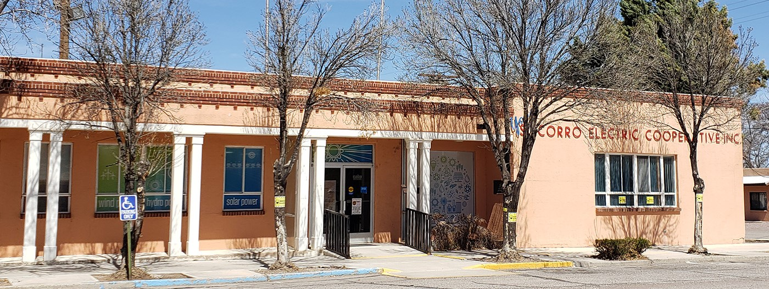

The Board of Trustees of The Socorro Electric Cooperative, Inc. (SEC) seeks a **visionary leader with strong interpersonal and team building skills** to become the next General Manager due to a recent retirement. The SEC Board has retained NRECA Executive Search to facilitate the search process.

# About Socorro Electric Cooperative

Incorporated in 1945, SEC is a distribution cooperative providing service to 13,083 meters and 8,638 members. Its service territory covers over 11,000 square miles and includes portions of seven counties in west central, New Mexico. With annual revenue exceeding $25 million, net plant over $90 million, and over 3,300 miles of distribution line, SEC is financially strong and continues to invest in its electric distribution and transmission facilities, while annually retiring member capital credits.

In addition to providing electric service to its members, SEC has recently begun construction of a fiber optic network to meet the needs of underserved areas within its service area. The smart grid infrastructure will facilitate gigabit-speed broadband service to SEC’s affected membership. Funding support for the project is provided by the Connect New Mexico Pilot Program, an effort of the New Mexico governor and the state’s Office of Broadband Access and Expansion.  SEC was one of four recipients awarded this grant. SEC has partnered with Continental Divide Electric Cooperative, to provide Red Bolt Broadband for its internet service.

SEC is a member of the Tri-State Power Cooperative (Tri-State), a generation and transmission cooperative serving utilities in Colorado, Nebraska, New Mexico and Wyoming. To help SEC meet its objectives regarding renewable energy, Tri-State provides a portion of SEC’s power supply through its green power program. Wind generation is the major source of that power, but SEC also receives a portion of its renewable portfolio from several small hydroelectric projects, as well as biomass facilities that utilize animal waste to create methane to fuel small generating plants.

To operate its electric system, SEC employees 36 full-time employees, with a portion of these being members of IBEW AFL/CIO local 611. Headquartered in Socorro, New Mexico, SEC operates with a vision of being conscientious stewards for its members, and it values clear and open communication both internal and external to SEC.

The GM of SEC provides leadership, advice, and assistance to the Board of Trustees concerning industry changes, strategic planning, business objectives, and policy needs that will support SEC’s mission, and values while providing effective guidelines for business operations now and in the future. The GM is responsible for creating an environment that encourages teambuilding and a cohesive work environment between the Board, management, and employees. Additionally, the GM directs SEC’s day-to-day operations and activities, ensuring that the business of the cooperative is conducted in accordance with SEC’s bylaws, policies, strategic plans, and business objectives.

**The Ideal Candidate**

The ideal candidate for the GM position at SEC will have a proven track record of success in the electric industry, strong leadership skills and a commitment to fostering a supportive and empowering work environmentwhere everyone has the opportunity to succeed and thrive.

# Leadership Competencies

* Commitment to cooperative values and principles.
* Ability to think strategically and position SEC for future success.
* Demonstrated expertise in building strong relationships with members and the community.
* Knowledge of power supply and financial issues related to cooperative operations.
* Proven leadership and management skills.
* Strong communication skills with the board, employees, members, and community stakeholders.
* Ability to motivate employees to build strong teams and to develop a positive work culture.
* Ability to establish and achieve challenging goals.
* A willingness to work hard and lead by example.
* An appreciation for small town environments.

# Experience and Expertise

* A Bachelor’s Degree is required.
* An advanced degree such as an MBA or graduation from the NRECA MIP program is a plus.
* Education or Experience in Accounting & Finance, Engineering or Business is preferred.
* A minimum of 5 years of progressively responsible leadership experience is preferred.
* At least 5 years of electric utility experience is required.
* CEO or GM experience is preferred but not required.
* An understanding of the dynamics of providing broadband is helpful.
* Knowledge of regional issues related to SECs power supply is valuable.

# Our Location

Socorro with over 9,000 residents, serves as the county seat and business center for Socorro County. Its location in the Rio Grande Valley and its elevation of 4,585 feet give it a pleasant year-round climate, but also provides four distinct but temperate seasons. Socorro is the home of New Mexico Tech University which is consistently rated as one of the nation’s best STEM universities. Socorro is located a short 75 miles from Albuquerque which offers all of the shopping, dining and entertainment venues of a large metropolitan area.

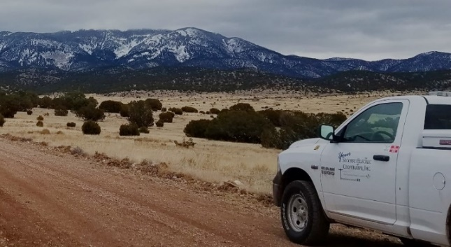  
The area boasts a diverse landscape characterized by forests, agricultural land and the Rio Grande River. The area provides ample opportunities for hiking, camping, and fishing. The Bosque del Apache National Wildlife Refuge is located a short distance from Socorro. This 57,331-acre refuge provides a critical stopover site for migrating waterfowl and is well known for the tens of thousands of cranes, geese, and ducks who winter there each year.

# Our Benefits

SEC provides its employees with an attractive and competitive benefits package which includes medical, dental, vision, basic and supplemental life, business travel, long-term disability, paid holidays, vacation, and sick leave. The retirement package is highly competitive and includes a traditional pension plan, a 401(k) plan and a 457(b) plan. Salary is commensurate with qualifications and experience.

# How to Apply

If interested, please apply at

<https://nreca.applytojob.com/apply/lvsN34F5TA/Socorro-Electric-Cooperative-General-Manager>

Applications must be received by **October 7, 2024** and are required to include the following: 1) Cover letter, 2) resume and 3) contact information, including email addresses, for 3 professional references. If you have any questions, please contact**Dave Luttrell,**NRECA Executive Search, Email: david.luttrell-contractor@nreca.coop.   
  
All replies are confidential.

**$25 million**

2023 revenue

**36**   
employees

**13,083**   
active meters